Diary No. 5

Week 6: On-Site

Topic: Play Testing

Date: 31/10/2020

Team Members: James Wilson, Reece Taylor, Ali Noorani

5.1 Evaluations and Assessment of Games and Players:

The serious pre-made game of their choice was “Kahoot”.

The questionnaire started off with easy questions such as “Have you played Kahoot before?” as seen in Figure 1.

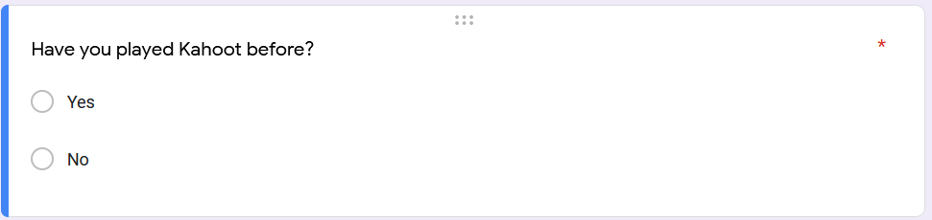Figure 1 The first question.

The questionnaire consisted of 10 questions in total with their types ranging from “yes or no” to “short text” based. Most of the questions consisted the Likert scale.

The questionnaire also asked some detailed questions about the fun and educational part of it as seen in Figure 2.

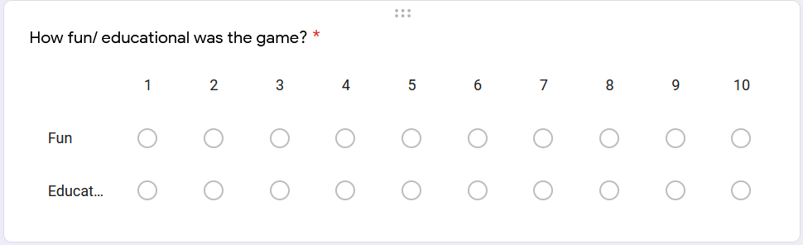Figure 2 Detailed questions. [A] How fun/ educational was the game?

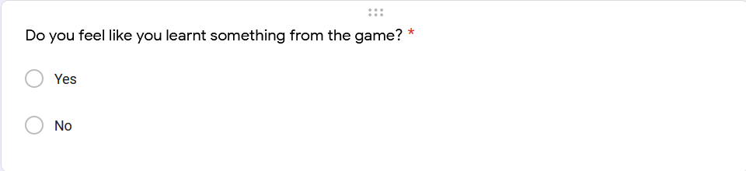[B] Did you learn something from the game?

At the end of the questionnaire, the team decided to have the final question as “any other feedback?” for the players to mention anything that the team may have missed.

5.2 Sending Out the Questionnaire:

The team sent out the questionnaire to a randomly chosen team for testing before sending it out to everyone else. This was to check for errors.

The review team came up with interesting answers, however there was a problem in the question: “What quiz did you take?” which was a short text based question. The answers came back as “many”, “a lot”, “many quizzes”. These are all similar answers with the same meaning, so the team changed the question from a short answer base to a multiple choice question where the choices were: “Maths”, “English”. “Science”, “Many quizzes” and “Other” where they could specify the quiz they took.

Once the questionnaire was fixed, the team sent it to the rest of the teams to have a go.

5.3 Data Collected:

The data the team collected can be seen in Figure 3:

Figure 3: Data Collected

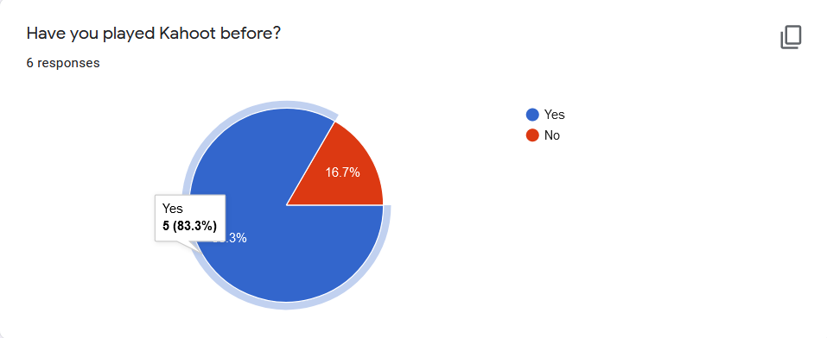

[A] Pie chart for the responses of “Have you played Kahoot before?”

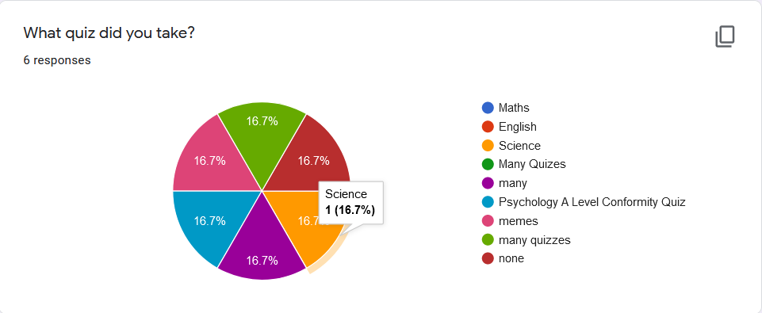

[B] Pie chart for “What quiz did you take?”

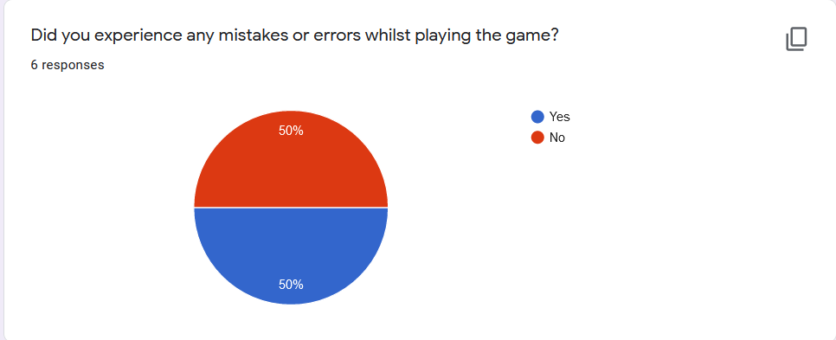[C] Pie chart for “Did you experience any mistakes or errors whilst playing the game?”

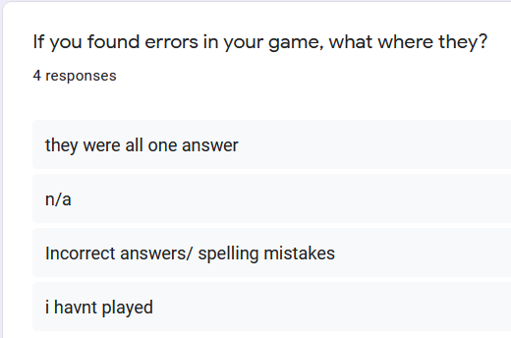[D] Pie chart for “If you found any errors, what were they?”

[E] Bar chart for “How did you find the gameplay experience?”

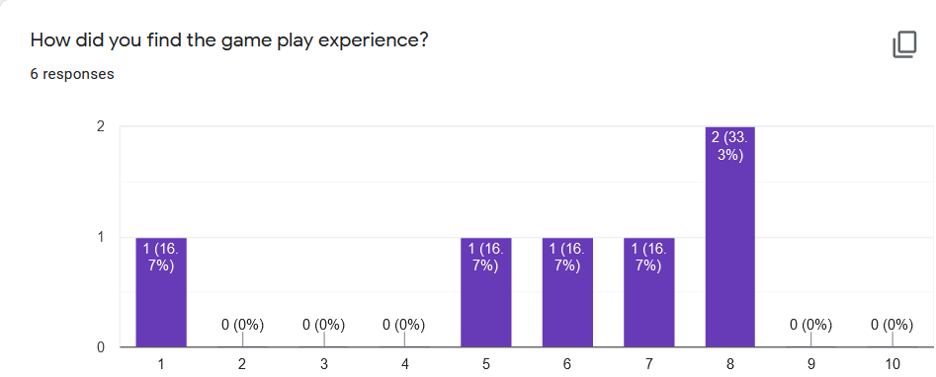

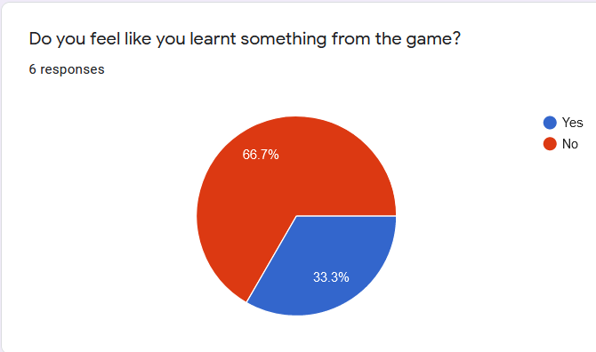

[F] Pie chart for “Do you feel like you learnt something from the game?”

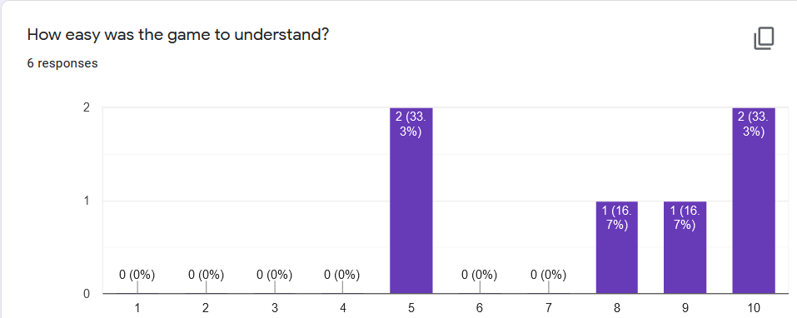[G] Bar chart for “How easy was the game to understand?”

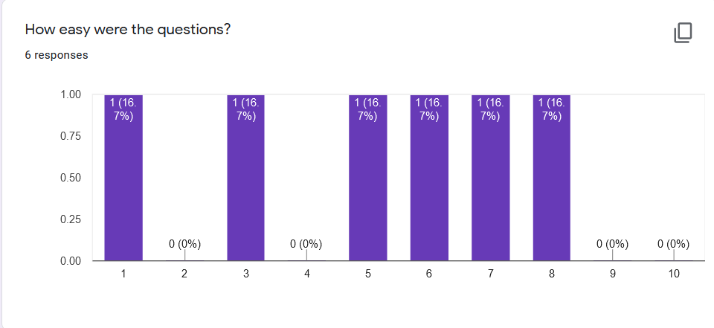

[H] Bar chart for “How easy were the questions?”

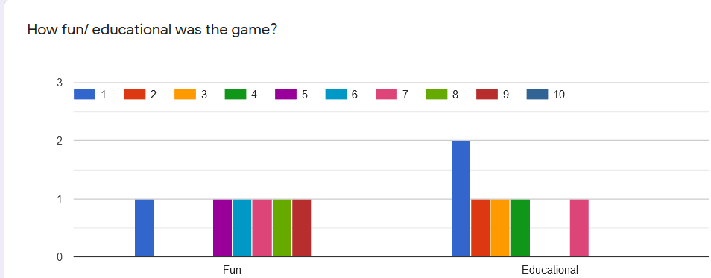[I] Comparison bar chart for “How fun/ educational was the game?”

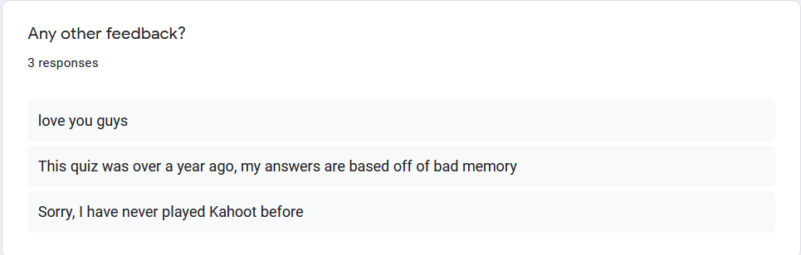[J] Long text question for “Any other feedback?”

5.4 Limitations and Strengths:

The team only managed to get 6 responses before the end of the play testing time.

To fix this from occurring next time, the team would send out the questionnaire through paper, online and on social media to get as many responses as possible.

Another change the team would make is to split some of the questions into two questions to make them easier to answer and to also collect data better.